Muhamad Assem Ahmed
Lab 20

Part A

LAB 20 — Lab ID: 27 | MIN_GPA_LAB = 2.5 | MAX_YEAR_LAB = 2

- StudentsController's two Create methods can share a name because MVC choose by [HttpGet]/[HttpPost] attributes at the action selection stage the framework picks the right overload before it ever needs a unique method name A Razor Pages class has no action selector handlers are located by reflecting over method names for the [Async] pattern
- Because Student is a property, it's visible to every handler on the page not just the one it was declared in and to the .cshtml view via Model.Student
- Returning the view/page after a successful POST still leaves the browser sitting on a POST request in its history Pressing F5 re-submits that exact request

Part B

anew form needs no data loaded from the database

Part D

Muhamad Assem with id 6 and year 2 and Gpa 2.5
A)
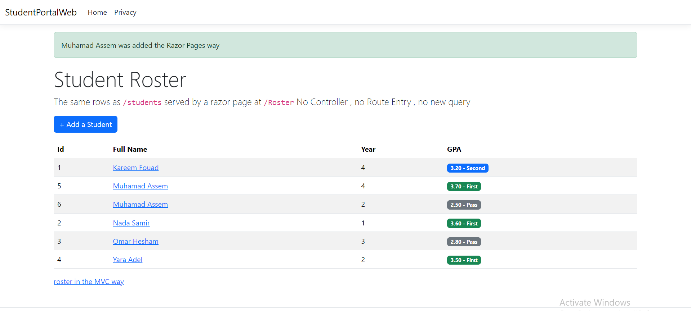

- No extra one submited
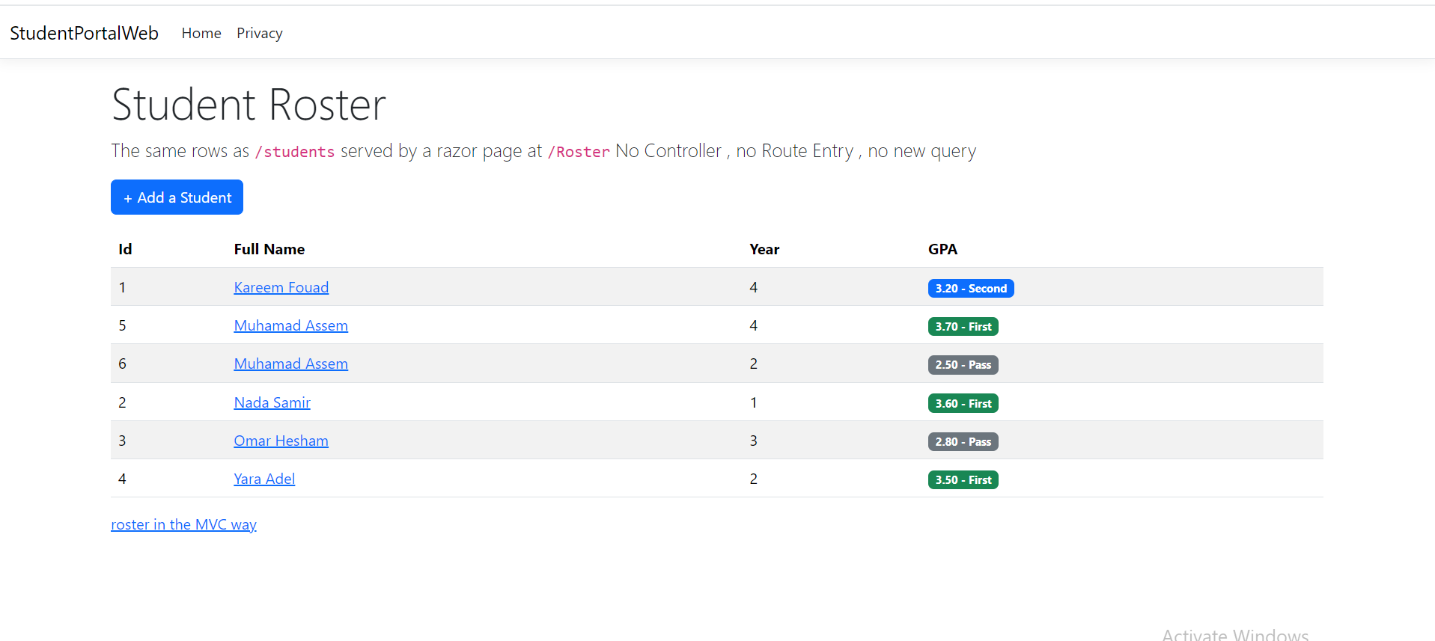

C)
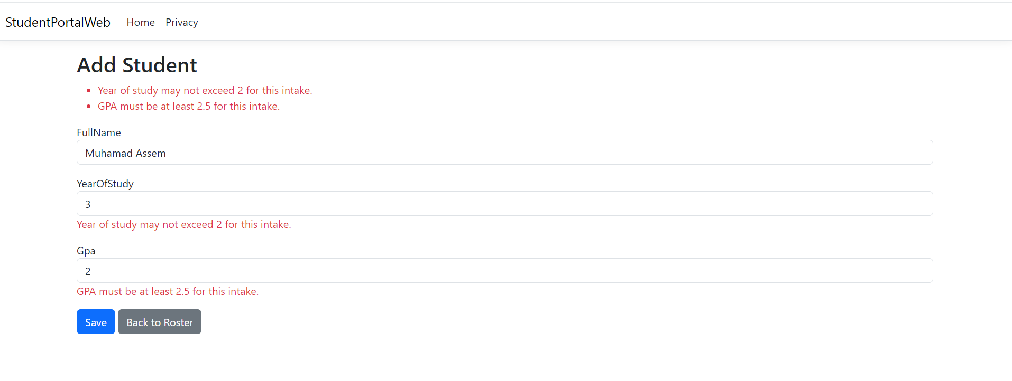

D)
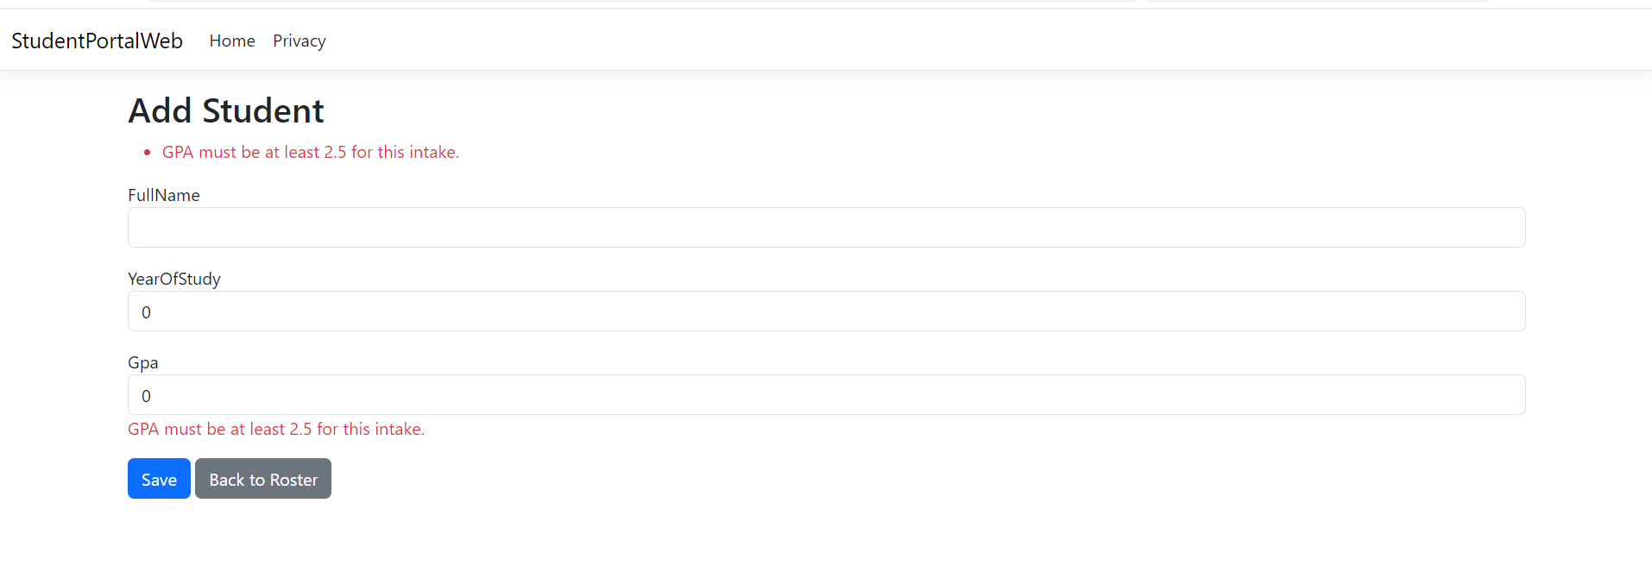
Student never gets bound from the post it stays the default new() (null FullName, YearOfStudy = 0, Gpa = 0.0). Since Student was never part of model binding it's also never part of automatic validation

